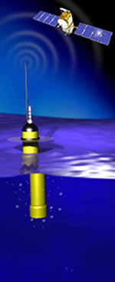
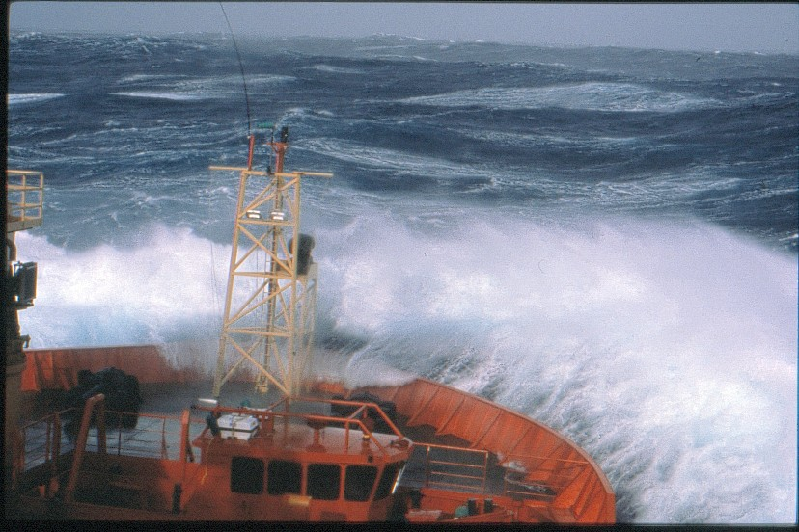
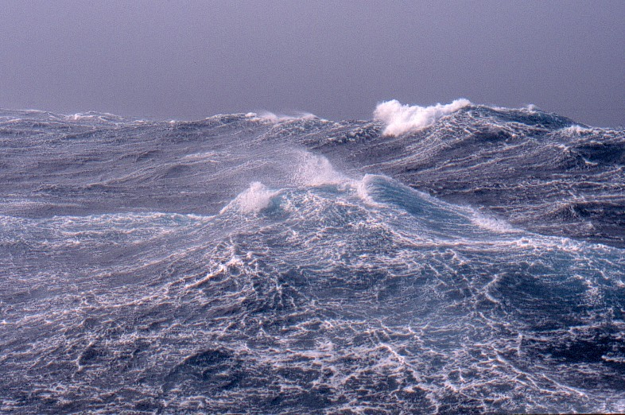

SEA2003F

Questions - Open Test 18th March 2008

- Oceanography is seen as a multidisciplinary science. Name 4 sciences that interact with oceanography.
- With the aid of a diagram explain the main difference between a passive and an active continental margin?
- What do magnetometers measure? And how can changes in the Earth’s polarity be measured?
- What does the abbreviation “CTD” stand for? Name 4 variables that can be measured or sampled?
- Outline the embryonic and mature phase of the Wilson cycle.
- Define sensible heat and latent heat.
- What is meant by the term “Carbonate Compensation Depth”? Why does calcareous ooze dominate areas close to shallow ridges?
- On the TS plot overleaf plot the following A= 35.25, 5.5°C, B= 27σ_{t}, 35.00, C= 26.5 σ_{t} 10.5°C, D=20°C, 31.00, E=26σ_{t}, 10°C and F= 23°C, 1022 kgm⁻³. In which order would they lie within a stratified column of water.
- Name 4 common ions in sea water.
- The oceans contain 1370 x 10⁶ km³ of water and the residence time of this water is 48,000 years. What is the rate of water entering the oceans through river outflow?

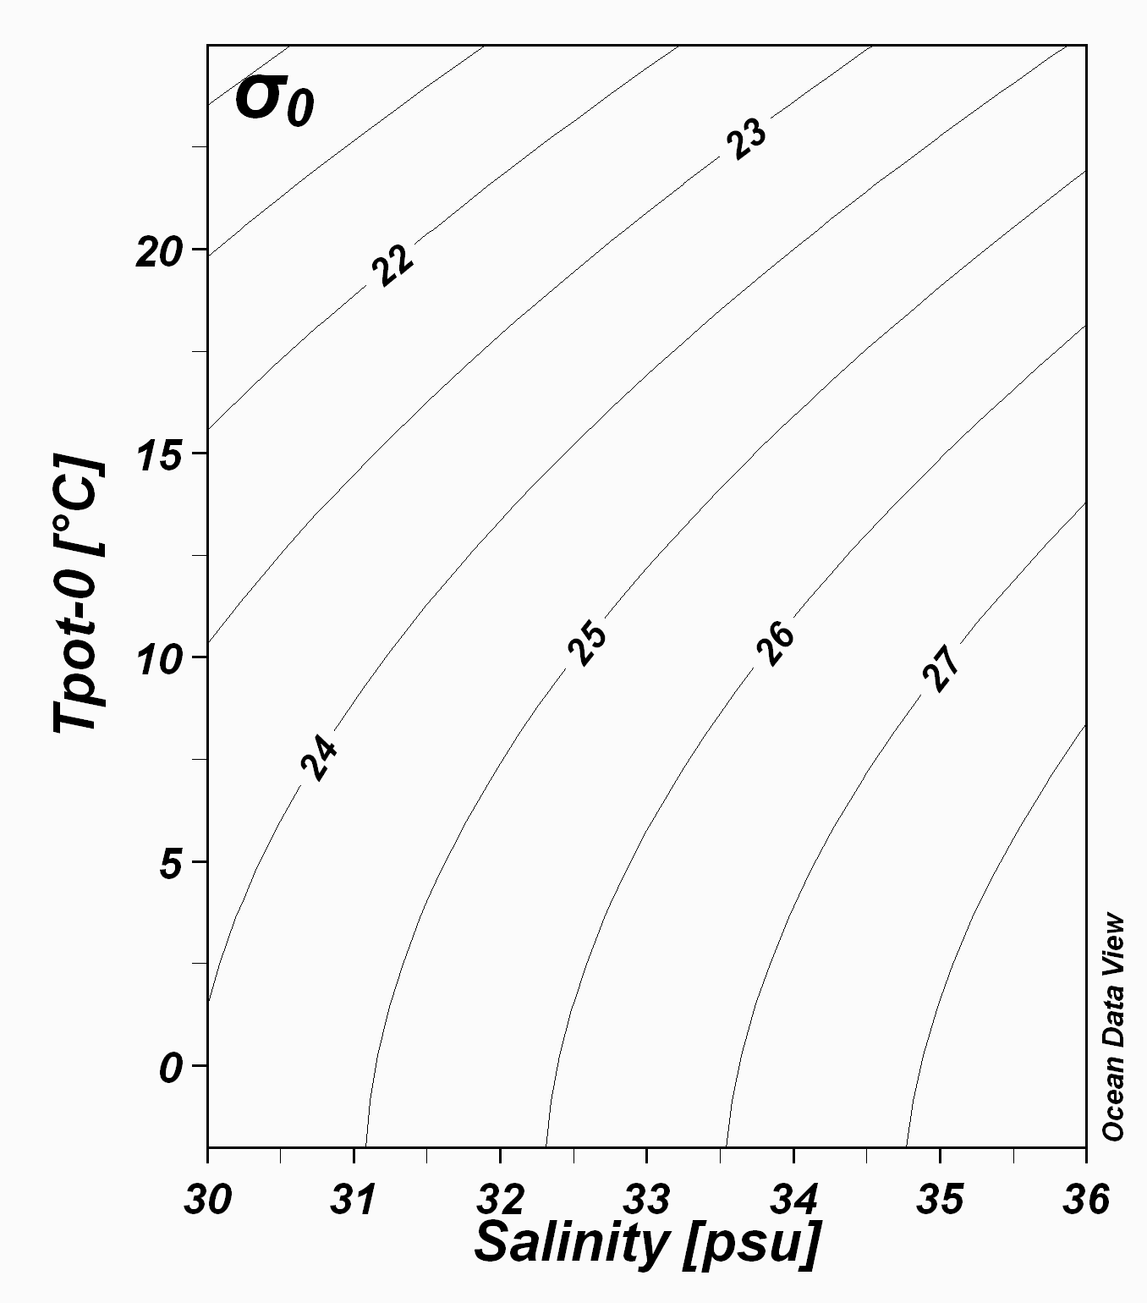

Name ____________________________________________

